32.45: a) 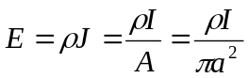, in the direction of the current.
b) 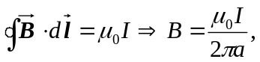 counterclockwise when looking into the current.
c) The direction of the Poynting vector 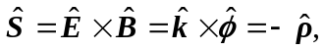 where we have used cylindrical coordinates, with the current in the z-direction.
Its magnitude is 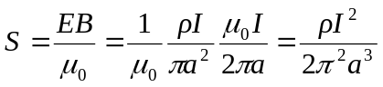.
d) Over a length l, the rate of energy flowing in is 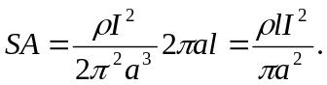
The thermal power loss is 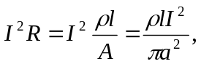 which exactly equals the flow of electromagnetic energy.

